National School of Sciences Lainchaur, Kathmandu


“ Portfolio Website ”

Submitted By: Chhabi Pandey D16 , 753
Submitted To:

Department of Computer Science National School of Sciences

Acknowledgement

I feel truly fortunate to have had the support of my teacher, Mr. Aneesh Karki, throughout this project. His encouragement, guidance, and helpful feedback made a big difference as I worked on building this portfolio website. I’m grateful for the time he took to explain things, answer questions, and keep me motivated during the process.
I would also like to thank all the faculty members for their support and suggestions throughout the project. A special thanks to the lab assistants for their help during practical sessions, which made the development process smoother and more manageable.

Chhabi Pandey

Certificate of Approval

It is certified that Mr. Chhabi Pandey has carried out the project work entitled “Portfolio Website ”.

This project is the result of his endeavors and research. It is finalized under our guidance and supervision in the academic year 2023-2024.

…………………………… …………………………
Head of Department Supervisor

Er. Sabin Raj Bagale Mr.Aneesh Karki
Department of Computer Science National School of Sciences
Department of Computer Science National School of Sciences
Lainchaur, Kathmandu, Lainchaur, Kathmandu, Nepal
Table of Content

Introduction 5

CodeUsed………………………………………………………………………………………..6-14

Conclusion………………………………………………………………………………………..15
References………………………………………………………………………………………...16
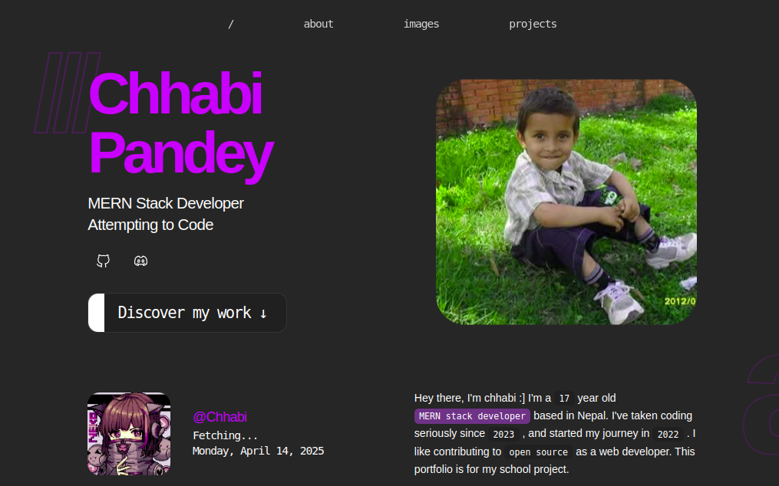
INTRODUCTION
This is a personal portfolio website I made as part of a school project at the National School of Sciences. My goal was to create something simple and clean that reflects who I am—my background, interests, what I’ve worked on, and what I’ve learned throughout the year in school.
I built the whole site using just HTML and CSS, focusing on how to structure content and style it in a way that looks good and feels easy to use. The site has sections like About Me, Projects, and Contact, and I tried to keep the design clean, organized.
This project really helped me get more confident with the basics of web design. It taught me how to build a website from scratch, and it’s been a great starting point as I continue learning more advanced tools and technologies.

https://chhabipandey.netlify.app

Code Used

Navigation Bar

HTML CODE :
<nav class="navbar">
<div class="navbar-container">
<ul class="navbar-list">
<li class="nav-item">
<button class="nav-button"
onclick="document.getElementById('home').scrollIntoView({behavior: 'smooth'})">

<h5 class="nav-text">/</h5>
</button>
</li>
<li class="nav-item">
<button class="nav-button"
onclick="document.getElementById('about').scrollIntoView({behavior: 'smooth'})">

<h5 class="nav-text">about</h5>
</button>
</li>
<li class="nav-item">
<button class="nav-button"
onclick="document.getElementById('aw').scrollIntoView({behavior: 'smooth'})">

<h5 class="nav-text">images</h5>
</button>
</li>
<li class="nav-item">
<button class="nav-button"
onclick="document.getElementById('code').scrollIntoView({behavior: 'smooth'})">

<h5 class="nav-text">projects</h5>
</button>
</li>
</ul>
</div>
</nav>

Output :



CSS Code :

.nav-item {
text-decoration: none;
list-style: none;
}

.nav-button {
background-color: transparent;
border: none;
color: white;
font-size: 1.1rem;
-webkit-user-select: none;
user-select: none;
display: flex;
align-items: center;
gap: .75rem;
padding: 13px 25px;
border-radius: 100px;
cursor: pointer;

}

.nav-text {
opacity: 0.8;
}

.nav-icon-container {
display: none;
}

Header Section

HTML Code :

<section id="home" class="wrapper hero-section">
<div>
<h1 class="hero-title">MOON</h1>
<h4 class="hero-subtitle">
MERN Stack Developer<br class="hero-subtitle"> Attempting to Code
</h4>
<div class="hero-socials">
<div class="socials-container">
<div class="social-item">
<a href="https://github.com/Mythsoul" target="_blank" rel="noreferrer"
class="social-link">
<i class="fa-brands fa-github"></i>

</a>
</div>
<div class="social-item">
<a href="https://discord.com/users/994964865238184007" target="_blank"
rel="noreferrer" class="social-link">
<i class="fa-brands fa-discord"></i>
</a>
</div>
</div>
</div>
<button class="cta-button button-with-side"
onclick="document.getElementById('code').scrollIntoView({behavior: 'smooth'});">
<div class="button-side"></div>
Discover my work ↓
</button>
</div>
<div class="profile-img-container">
<div class="profile-img"> <img src=’./profile.png’> </img> </div> </div>
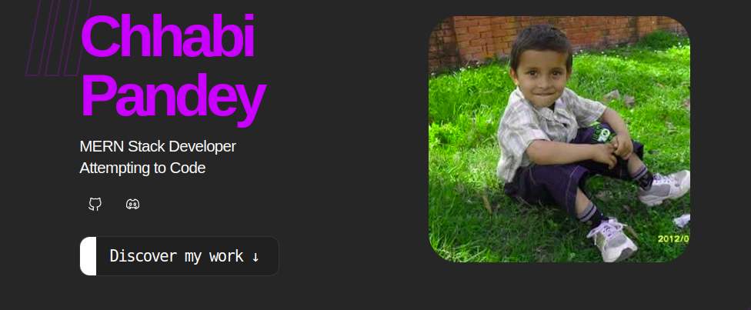

Output:

CSS Code :

.hero-section {
scroll-margin-top: 20rem;
display: flex;
justify-content: space-between;
align-items: center;
margin-bottom: 5.75rem;
margin-top: 7rem;
}

profile-img {
border-radius: 48px;
width: 425px;
height: 400px;
z-index: 1;
display: block;
align-self: start;
background-size: cover;
background-position: center;
background-repeat: no-repeat;
}

@keyframes float-animation {
0% {
transform: translateY(7px);
}
50% {
transform: translateY(-7px);
}
to {
transform: translateY(7px);}}

About Section

HTML Code :

<section id="about" class="wrapper bio-section">
<div>
<h2 class="about-heading">activity</h2>
<div class="about-container">
<img src="./art/profile.png" alt="@Mooniee"
class="about-avatar">
<div class="about-info">
<h3>@Chhabi</h3>
<h5>Fetching...</h5>
<h5>
<script>document.write(new Date().toLocaleDateString('en-US', { weekday: 'long', year: 'numeric', month: 'long', day: 'numeric' }));</script>
</h5>
</div>
</div>
</div>
<div class="bio-text">
<h2 class="bio-heading">bio</h2>
<p>
Hey there, I'm Chhabi :] I'm a <span class="bio-highlight">17</span>
year old <br>
<span style="background-color: #685380;" class="bio-highlight">MERN stack developer</span>
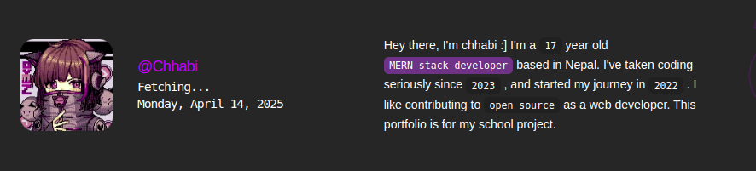
based in Nepal. I've taken coding seriously since
<span class="bio-highlight">2023</span>
, and started my journey in <span class="bio-highlight">2022</span>
. I like contributing to
<a href="https://github.com/Mythsoul"
class="bio-link">
<span class="bio-highlight">open source</span>
</a>
as a web developer. And this is My project for personal portfolio

</p>
</div>
</section>

Output :

CSS Code :

.bio-section {
margin-bottom: 6rem;
display: grid;
gap: 4.5rem;
grid-template-columns: 1fr 1fr;
align-items: center;
}
.bio-text {
position: relative;
line-height: 1.75rem;
}
.bio-highlight {
font-weight: 400;
font-size: .9rem;

border-radius: 7px;
color: black;
padding: .2rem .5rem;
width: fit-content;
}
.bio-link {
text-decoration: none;
}
.bio-heading {
display: none;
margin-top: 1rem;
}

Projects Section
HTML Code :

<section class="wrapper" id="code">
<div class="projects-title" d>
<h2 class="project-heading">
<span class="project-accent">code</span>
:work
</h2>
</div>
<div class="projects-grid">
<div class="project-card">
<div class="project-header">
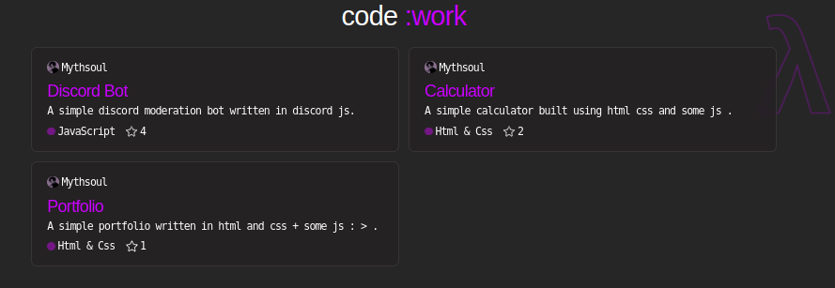
<div class="project-info"><img src="https://github.com/Mythsoul.png"
alt="Mythsoul's profile picture" class="project-avatar">
<h6>Mythsoul</h6>
</div>
<div class="project-open">

</div>
</div>
<div>
<h3>Calculator</h3>
<h6>A simple calculator built using html css and some js . </h6>
</div>
<div class="project-info-container">
<div class="project-info"><span class="tech-dot"
style="background-color: rgb(110, 74, 126);"></span>
<h6>Html & Css</h6>
</div>
<div class="project-info">
<i class="fa-regular fa-star"></i>
<h6>2</h6>
</div>
<div class="project-info"></div>
</div>
</div>
</div>
// other projects showcase are in same order
</section>

Output :

CSS Code :

.projects-title {
display: flex;
justify-content: center;
margin-top: 0;
}
.project-card {
padding: 1rem 1.25rem;
border-radius: 8px;
min-height: 140px;
height: 100%;
display: flex;
flex-direction: column;
gap: .25rem;
justify-content: space-between;
backdrop-filter: blur(5px);
-webkit-backdrop-filter: blur(5px);
background-blend-mode: overlay;
border: 1px solid black;
}
.project-card:hover {
transform: translateY(-2px);
box-shadow: 0 15px 25px -10px #00000040;
}
.project-info {
display: flex;
gap: .2rem;
align-items: center;
}
.project-info-container {
display: flex;}

Footer Section
HTML Code :

<footer class="wrapper footer">
<div class="socials-container">
<div class="social-item">
<a href="https://github.com/Mythsoul" target="_blank" rel="noreferrer"
class="social-link">
<i class="fa-brands fa-github"></i>
</a>
</div>
<div class="social-item">
<a href="https://discord.com/users/994964865238184007" target="_blank" rel="noreferrer"
class="social-link">
<i class="fa-brands fa-discord"></i>
</a>
</div>
</div>
<h6 class="footer-text">
Made with pain. &lt;3
<span class="footer-badge">V1</span>
</h6>
</footer>

Output :

CSS Code :

.footer {
padding-bottom: 2.4rem;
display: flex;
justify-content: space-between;
align-items: center;
}
.footer-text {
text-align: center;
line-height: 2.5rem;
margin-top: 0;
}

Conclusion

In conclusion, creating this personal portfolio website was a successful and rewarding experience. The webpage was built using only HTML and CSS, and I focused on making it visually appealing and well-structured.
This project helped me gain a deeper understanding of how HTML and CSS work together to create both the layout and the visual design of a website. I learned how to organize content logically, apply styling effectively, and build a clean, responsive webpage using just the basics.
Overall, it was a great opportunity to strengthen my foundational web development skills and take one step closer to becoming a better developer.

REFERENCES

- Claude AI: Used for guidance and feedback during development.
- YouTube: Watched tutorials such as "How to Make a Good Portfolio Using HTML and CSS" to understand layout and design practices.
- CSS Gradient: Used “ CSS Gradient Generator ” to create smooth background gradients for the site.
- Discord: Asked for help and received suggestions from various users. I also took inspiration from different personal portfolios shared by members of developer communities.

